GarageCopilot — Solution Doc
Oct 1, 2026 · @Gaurav

Pitch and problem
GarageCopilot (working name) is a hands-free, voice-first AI back office for Indian two- and four-wheeler garages. Mechanics talk to it through a Bluetooth headset; it opens job cards, checks stock and prices, gets customer approval for extra work, and keeps the owner's books and the customer's status page up to date. Theme: Future of Work & Enterprise Productivity.
- Problem: in a small garage the mechanic is also the storekeeper, estimator and phone operator. Every stock check, price lookup or "can we go ahead?" call means stopping work, washing hands and picking up a phone. Jobs stall waiting for customer replies, and the owner has no live view of jobs, stock or time spent.
- Buyer: the garage owner (efficiency, fewer disputes, stock control). User: the mechanic (never touches the phone). Beneficiary: the vehicle owner (live status, itemised quotes, nothing done without consent).
- Positioning: workflow augmentation, not diagnostics. Light Q&A about a vehicle is allowed; repair diagnosis is out of scope.

Demo story (the 3-minute video)
One bike, one mechanic, hands never touch the phone:
- Intake: "New bike, Splendor Plus, MH12 AB 1234, owner Ramesh, 98xxxxxx, complaint: clutch slipping, general service." A job card is created and Ramesh gets a WhatsApp-style link to a live status page.
- Status updates: "Moving it to washing" / "Started service." The page timeline updates and time per stage is logged.
- Stock check: "Do we have a clutch plate set for Splendor? Price?" Agent: "Two in stock, ₹650, labour ₹300."
- Approval: the job is over the pre-approved budget, so the agent sends Ramesh an itemised quote. He taps Approve; the mechanic hears "Ramesh approved, go ahead."
- Auto-logging: "Used one clutch plate set." Stock decrements; the job bill updates.
- Close-out: "Job done." Final bill to the customer, status page shows ready for pickup, owner dashboard shows the job closed and stock low.
Stretch, if time allows: a customer asks "how much for a brake pad change?" via the web voice agent; it drafts a quote, confirms it with the owner by voice, and replies.

Features and scope
Must-haves ship by Oct 15; stretch only after the demo path works end to end.
Feature | What it does | Scope
Voice copilot (mechanic app) | Mobile web app, Bluetooth headset, Hindi / English / Hinglish, push-to-talk fallback | Must
Job cards | Create from voice; vehicle, owner, phone, complaint, stage, mechanic, timestamps | Must
Customer status page | Public link per job: timeline of stages, quote, final bill | Must
Inventory Q&A + updates | "Do we have X? Price?"; parts used decrement stock; low-stock flags | Must
Quote + approval | Itemised parts + labour; customer approves on a web page; mechanic told by voice | Must
Owner dashboard | Open jobs by stage, pending approvals, low stock, time per job, day's revenue | Must
Audit log | Every agent action recorded with who, what, when | Must
WhatsApp delivery | Send status link and quote via WhatsApp (sandbox or simulated send in demo) | Stretch
Customer voice agent | Inbound price queries via web voice, owner confirms quote | Stretch
Light vehicle Q&A | Torque specs, service intervals, grounded answers | Stretch
Telephony, payments, multi-branch, diagnostics | — | Out

Architecture
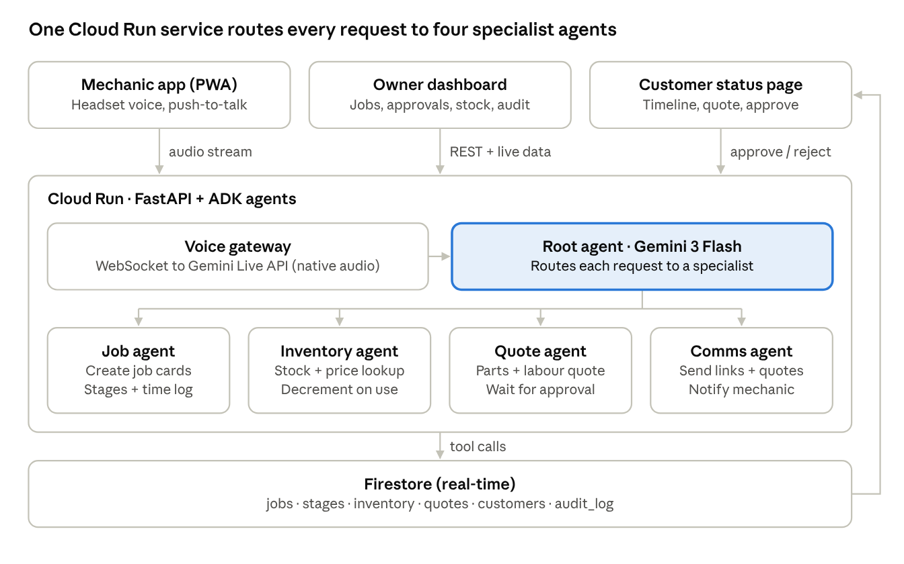
architecture · 3 clients, 1 service, 4 agents
Every agent action writes to Firestore, and real-time listeners push changes to the dashboard and status page, so nobody refreshes anything. Quotes above a per-garage threshold always pause for customer approval; the audit log records each tool call.

Tech stack
All-Google, as the rules require (Gemini models, deployed on GCP).
Layer | Choice | Notes
Voice | Gemini Live API (native audio), streamed over WebSocket | Hindi/Hinglish; test with real garage noise in week 1
Reasoning | Gemini 3 Flash (fast tool calls); Gemini 3.1 Pro for quote drafting if needed
Agents | ADK (Gemini Enterprise Agent Platform), orchestrator + 4 specialists | Tools are plain Python functions over Firestore
Backend | Python FastAPI on Cloud Run | One service: agent, REST API, WebSocket
Data | Firestore: garages, jobs, stages, inventory, quotes, customers, audit_log | Real-time listeners drive the dashboard and status page
Frontend | Next.js or React on Firebase Hosting: mechanic app (PWA), owner dashboard, customer page | Shared Firebase Auth for owner and mechanic
Messaging | Approval link by SMS/WhatsApp sandbox; simulated send for the demo | Swap in WhatsApp Business API later
Observability | Cloud Logging + the audit log shown in the dashboard | Supports the auditability story
Repo / CI | Public GitHub repo, Cloud Build deploy on push | Required deliverable

Build plan and owners
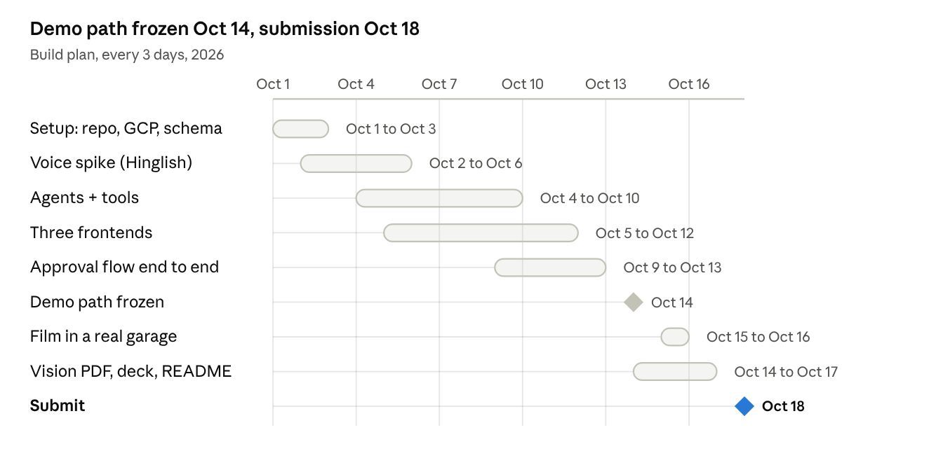
build plan · Oct 1 to Oct 18
The whole demo path must work by Oct 14; the last four days are for filming and documents only.
- Member A (backend + AI): Cloud Run service, ADK agents and tools, Firestore schema, Gemini Live voice gateway, audit log.
- Member B (frontend + demo): mechanic PWA, owner dashboard, customer status and approval page, video, deck, vision PDF.
- Both: seed data (one garage, ~30 parts with prices), a daily 15-minute sync, test on a real headset every other day.
Submission checklist (due Oct 18, 2026)
- ☐ Deployed prototype link (Cloud Run + Firebase Hosting)
- ☐ Public GitHub repo with README and setup steps
- ☐ Public demo video, under 3 minutes
- ☐ Vision document (PDF)
- ☐ Pitch deck

Judging fit, risks, open decisions
Criterion (weight) | How we score
Technical merit & Gen AI (40%) | Live voice + multi-agent ADK with real tool calls, human-in-the-loop approval, audit trail
Problem alignment & impact (25%) | Mechanic time saved per job; fewer stalled jobs; transparent pricing for customers
Innovation (25%) | Hands-free agent for an informal-sector workforce, in Hinglish
UX & design (10%) | Zero-touch for the mechanic; one-tap approval for the customer
Risks and fallbacks
- Speech in a noisy garage → push-to-talk, short confirmations ("Got it: clutch plate, ₹650"), test real audio by Oct 6.
- Live API latency or session limits → fall back to record-and-send voice turns.
- WhatsApp approval delays → approval via web link; WhatsApp is only the delivery channel.
- Looks like a CRUD app → film a real mechanic with greasy hands; show the agent doing the calling.
Open decisions
- ☐ Final product name
- ☐ Next.js vs plain React for the three frontends
- ☐ One real garage to film the demo in (who and when)
- ☐ Confirm the theme change is accepted on the portal

